Press release

Keller & Kalmbach reports record sales and strengthens market position

Unterschleissheim, February 08, 2022: Keller & Kalmbach looks back on a successful fiscal year 2021. Despite the challenging economic situation, which was characterized by severe supply bottlenecks, the company managed to realize a sales record. The family-owned company increased its consolidated sales by 20% to around 350 million euros in fiscal 2021. In addition, the full-service provider for C-parts acquired important manufacturing expertise with the acquisition of HEMA Umformtechnik GmbH & Co. KG in Schömberg, Germany, and positioned itself on the Scandinavian market with the takeover of Fameco Holding AB in Gothenburg, Sweden. With the new CEO at the top, Hans van der Velden, the international activities are being driven forward and the innovative company has sophisticated advanced analytics tools to secure the supply chain and thus the security of supply of its customers even better.

"In my 46 years at Keller & Kalmbach, I have never seen a deep crisis turn into a period of strong growth, immense price increases and major supply difficulties in such a short time," says Dr. Florian Seidl, the company's managing partner, summing up the 2021 financial year. Keller & Kalmbach took advantage of the challenges last year and set the course for the future. With consolidated sales of 350 million euros, a new record was achieved, corresponding to a CAGR (compound annual growth rate) of 4.7%. With Hans van der Velden, Seidl, who is leading the company in its third generation, also has a new CEO at his side since June 1, 2021, and will now continuously withdraw from operational management as well as move to the Supervisory Board.

Market position strengthened by manufacturing expertise
With the acquisition of HEMA, as one of the market leaders for high-quality fasteners and cold formed parts, Keller & Kalmbach for the first time acquires direct manufacturing competence. In the future, this will enable the company to offer high-quality fastening technology quickly and in line with customer requirements, independently of external production capacities. The targeted reinforcement of its trading, logistics and service expertise through the manufacturing competence increases the C-parts specialist's competitiveness and enables it to align itself even better to customer needs, thus expanding its market position.

Keller & Kalmbach positions itself in Scandinavia
With the acquisition of Fameco Holding, based in Gothenburg, Keller & Kalmbach expanded its presence to the Swedish market last year and is now also increasing its focus on expanding its business relationships in Scandinavia. "We are excited about the quality and dynamism of the Fameco team, which will strengthen the Keller & Kalmbach family," says Seidl. The company has many years of experience, especially in Sweden, in the industrial supply of small parts, such as screws, bolts, washers or critical fasteners.

Advanced analytics ensures reliable future forecasts and supply
As a result of the pandemic, digitalization processes were driven forward at a speed like never before. Keller & Kalmbach, for example, also focused on better data quality and a high level of automation, as well as the development and introduction of comprehensive advanced analytics tools that ensure greater transparency and solid planning reliability within the company and for customers. In particular, changes in the supply chain at customers can be perceived more quickly and immediate reactions can be derived. All this serves to ensure supply security for customers in a highly dynamic environment - the so-called large-scale challenges in the C-parts supply chain.

Overall, Keller & Kalmbach used the 2021 financial year very intensively to focus on customer needs more than ever before, to leverage synergy effects throughout the Group, and launched comprehensive digitization projects.

Characters: 4,169

Company profile Keller & Kalmbach GmbH
At Keller & Kalmbach, tradition meets innovation. Founded in Munich in 1878, the company is one of the leading specialists in fastening technology and is an expert in intelligent C-parts management. With 900 employees worldwide, the family-owned company ensures automated supply and optimization of material flow and supply chain for customers in the automotive and commercial vehicle industry, mechanical and plant engineering, the railroad industry and the agricultural and construction machinery industry.

Picture material for download under:
https://keller-kalmbach.com/unternehmen/presse/pressemitteilung/umsatzrekord

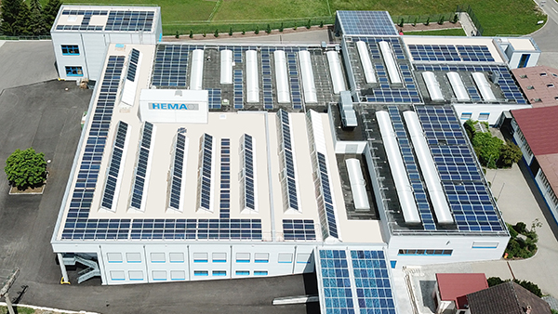

Image name: Hema-Gebaeude.jpg
Caption: With HEMA Umformtechnik GmbH & Co. KG in Schömberg (Germany), Keller & Kalmbach now has its own production facility for fasteners and fastening technology.

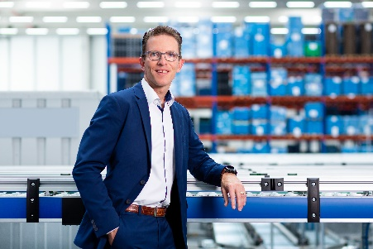

Image name: CEO_Hans_van_der_Velden.jpg
Caption: As CEO, Hans van der Velden is driving internationality forward as well as the digitalization of processes in the family-owned company Keller & Kalmbach.

Press contact
André Kranz
Head of Marketing and eBusiness
Phone +49 (0)89 8395-159
andre.kranz@keller-kalmbach.com

Keller & Kalmbach GmbH
Siemensstraße 19
85716 Unterschleißheim
Germany
www.keller-kalmbach.de

